

Audition Requirements
Updated, Fall 2026
Your choral audition will consist of the following elements:
“Oh Shenandoah” – Choose a key that best showcases your voice. You will sing “Oh Shenandoah” without accompaniment.
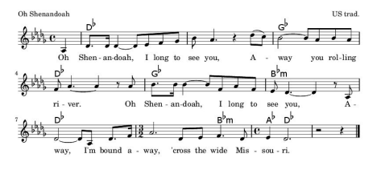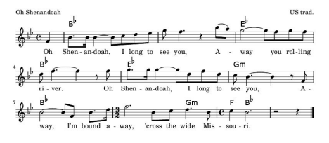
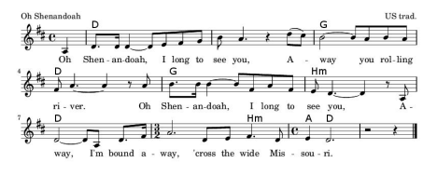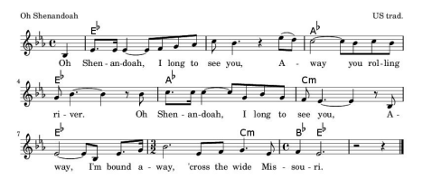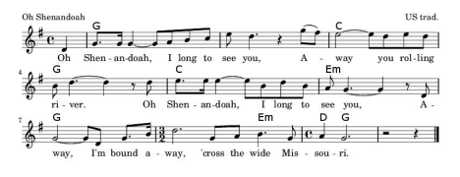

During your on-campus audition, you will be assessed in the following areas:
Ability to sight read in both major and minor keys using solfege (Movable or fixed do) (Do or La based minor)
Tonal Memory
Vocal tone
Intonation
Vocal Range/Tessitura
Singing Technique
Students who do not plan to be music majors but wish to sing in SAU choirs do not need to prepare an additional solo.
For prospective voice majors: Sing a prepared piece suitable for a recital or contest. You might consider a selection from 24 Italian Songs and Arias, the First Book of
Soprano/Mezzo/Tenor/Baritone Songs, or the Selected Solos for Contest series. Please bring an extra copy of your music. An accompanist will be provided for your audition.

Dr. Justin Nelson
jrnelson@saumag.edu

