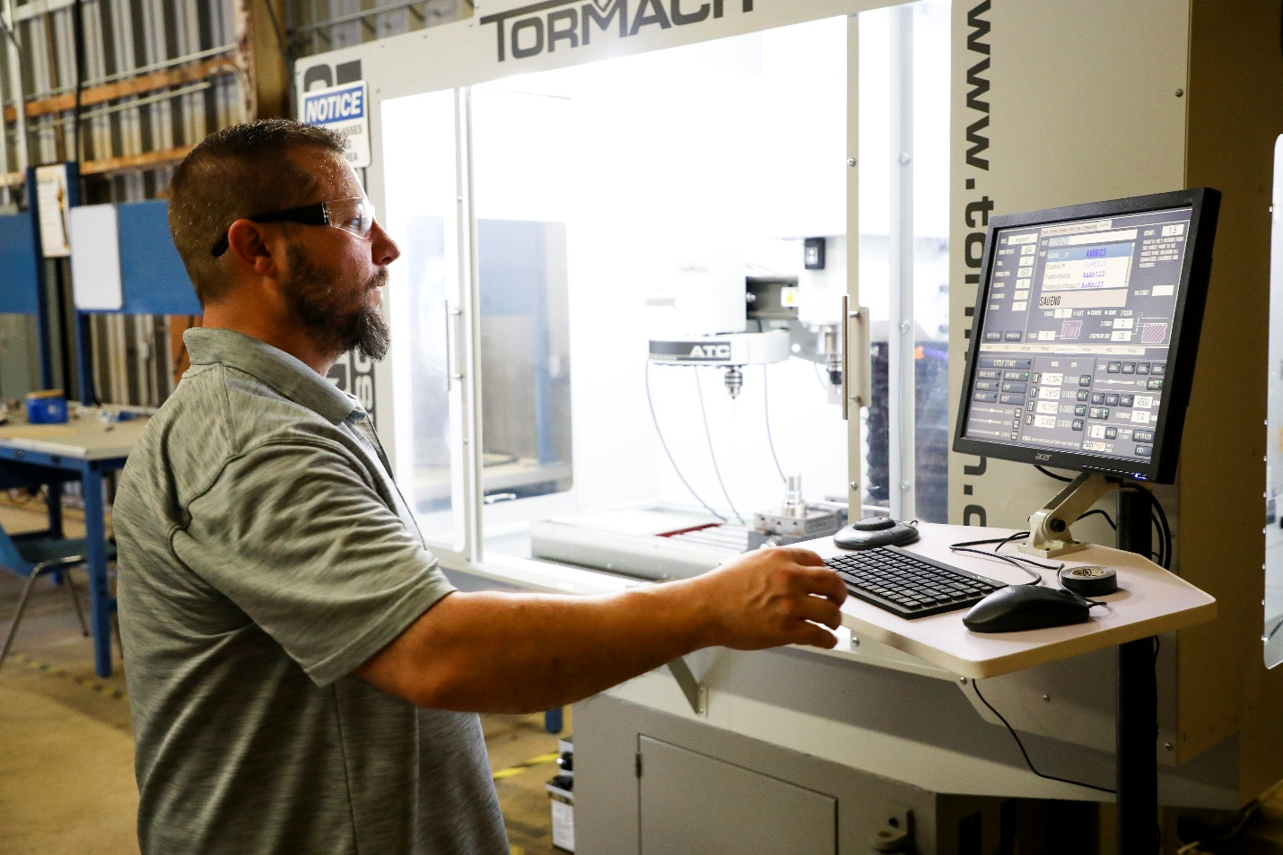
Student Performance & Achievement Information
As part of the Technology Programs’ commitment to continuous improvement and accreditation standards, student performance and achievement data are maintained and reviewed regularly by the technology programs.
This information supports program assessment, student success initiatives, and compliance with ATMAE accreditation requirements.



Program Retention & Graduation Rates
Industrial Technology (ITEC)
Year | Freshman Retention Rate | Sophomore Retention Rate | Junior & Senior Retention Rate | Overall Retention Rate | Graduation Rate
 |  |  |  |  | 4-Year | 6-Year
2019 | 67% | 78% | 93% | 86% | 33% | 33%
2020 | 50% | 100% | 90% | 88% | 50% | 50%
2021 | 100% | 57% | 91% | 86% | 50% | NA
2022 | 0% | 57% | 88% | 66% | 0% | NA
2023 | 50% | 88% | 94% | 89% | NA | NA
2024 | 100% | 88% | 92% | 91% | NA | NA

Engineering Technology (ETEC)
Year | Freshman Retention Rate | Sophomore Retention Rate | Junior & Senior Retention Rate | Overall Retention Rate | Graduation Rate
 |  |  |  |  | 4-Year | 6-Year
2019 | 44% | 0% | 100% | 71% | 20% | 40%
2020 | 50% | 100% | 100% | 93% | 0% | 0%
2021 | 0% | 67% | 100% | 85% | 0% | NA
2022 | 50% | 100% | 100% | 90% | 50% | NA
2023 | 20% | 100% | 100% | 60% | NA | NA
2024 | NA | NA | 100% | 100% | NA | NA

Career Placement Rates
Engineering Technology: 100% (last 5 years)
Industrial Technology: 95% (last 5 years)*
* 66 ITEC graduates from the last 5 years surveyed, 38/66 = 57.6% responded. 100% of responders secured employment. 36/38 = 95% of the responders job was related to their major.
Program | Placement Rate (last 5 years)
Industrial Technology (ITEC) | 95%
Engineering Technology (ETEC) | 100%

Mean Grade Point Averages of the Graduating Class & Average Years to Complete the Degree
Industrial & Engineering Technology (ITEC & ETEC)
Year | ITEC Mean GPA | ETEC Mean GPA | ETEC Avg Years to complete | ETEC Avg Years to complete
2020 | 2.78 | 2.36 | 5.17 years  Over the period 2021 – 2026, includes beginning SAU freshmen (4.27 yrs) and transfers (5.52 yrs) | 5.71 years  Over the period 2018 – 2026, includes beginning SAU freshmen (5.33 yrs) and transfers (5.87 yrs)
2021 | 2.81 | 2.81
2022 | 2.69 | 2.85
2023 | 3.00 | 2.96
2024 | 3.04 | 3.59
2025 | 2.94 | 2.88
Tuition Expenses to Complete the Program
Based on the 2025-2026 cost of attendance (15 hrs) at the Southern Arkansas University – Magnolia
Program | In-State | Out-of-State
Industrial Technology (ITEC) | $5100 | $8040
Engineering Technology (ETEC) | $5100 | $8040
Tuition & Fees 2025-26: https://web.saumag.edu/files/2025/08/SAU_FeeSheet2025_26.pdf
Cost Calculator: https://web.saumag.edu/admissions/cost-calculator/

Availability of Awards/Scholarships
https://web.saumag.edu/admissions/apply/scholarships/

