UNIVERSITY INJURY REPORT
BE DETAILED. USE BLUE OR BLACK PEN ONLY. SUBMIT COMPLETED REPORT TO YOUR ADVISOR.
Person Completing Report: ___________________________ Phone: ___________________________________
Injured Person: ________________________ Phone: ___________________ E-Mail: ______________________
STUDENT ID#: ________________________ Parent/Guardian Phone: ___________________________________

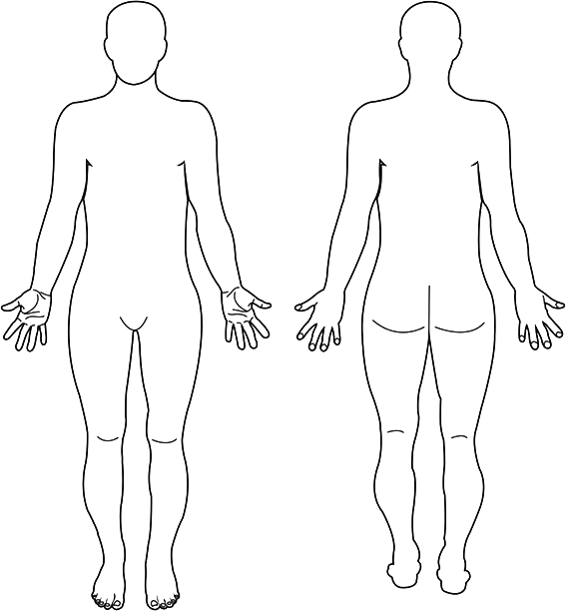
Injury (Circle body part(s) and describe injury):

Pertinent Medical Information (Has injury occurred before?):

How Accident Occurred (Describe. Include program area/group & activity): Date: _________ Time: _________

Location of Accident (Describe):


Diagram Location of Site Where Accident Occurred:

Person Taking Action: ________________________________ Phone: __________________________________
Action Taken/Assistance Given:

Emergency Services
911 called? 911 called by staff?
UPD called*? 911 care refused by participant?
Participant refused care by Club Sport staff?
*If Emergency Care Services (911) is called, ensure that UPD is also notified at the same time.
Always inform injured participants that they should seek further medical attention if their injury lasts or worsens. Staff are not medical professionals and therefore cannot make a diagnosis of any kind.
Witnesses
Name: __________________________ Phone: ______________________ E-mail: ________________________
Name: __________________________ Phone: ______________________ E-mail: ________________________

I will NOT hold Southern Arkansas University or the Club Sport Administration/Staff liable for any injury resulting from treatment provided. I understand that the Club Sport Administration/Staff are not medical professionals and cannot diagnose my condition; therefore, I am advised to seek further medical treatment. I have read this report and agree that the information is accurate.
Injured Participant’s Signature: _________________________________ Date: _______ /______ / ___________

Additional Comments:

Official Use Only:
Participant Follow Up YES NO Date Time
Left message/E-mail (circle medium used) ____ ____ ________ ______
Spoke to Injured Participant ____ ____ ________ ______
Spoke to Parent/Guardian ____ ____ ________ ______
Additional Notes:

SUBMIT COMPLETED FORM TO CLUB SPORT ADMINISTRATION Date Submitted: __________

